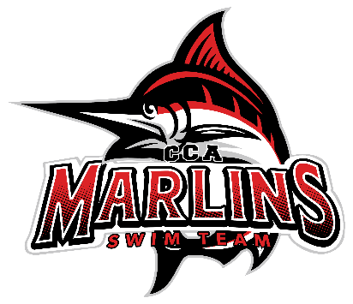
Marlins Board Meeting Minutes Recap (6/17/25)
**Attendance**: Coach Steven, Coach Amina, Coach Buffy, Coach Jamie, Brooke, Whitney, Juliet
1. **Finances**
- Julie and Carrie were unavailable; finances were sent for board review and will be discussed at the next meeting.
2. **Coach Updates**
- Coach Buffy (Silver Group):
- A few swimmers are transitioning to the Gold group, and others are moving up from the Bronze group.
- Averaging 8 swimmers per practice.
- Coach Jamie (Bronze Group):
- Currently averaging 2-3 swimmers per practice with varying skill levels.
- Coach Amina (JAG): Updated for Coach Casey-
- Noted a drop in numbers, which is typical for summer months.
- Coach Steven (Gold and Senior Groups):
- Attendance has been sporadic, but everyone is doing well.
- Some swimmers are pulling out of dryland sessions; discussions on strategies to keep them engaged are ongoing.
- Coach Susan (Mini Marlins):
- Updated by Amina; the program is going okay. Currently offering only private lessons, no group lessons.
3. **Training Trip Update**
- Seven swimmers participated and performed excellently.
- Special thanks to generous donors, Summit Contracting and National Pools, for making the trip more affordable for the team.
4. **Falon Park Update**
- No issues reported regarding senior drivers or outsiders.
- Coach Steven escorted one swimmer to their car due to an unknown individual in the parking lot.
5. **Preparation for District Meet at Liberty (July 11-13)**
- Meet invite has been sent out.
- Expected attendance is lower compared to other districts.
- A new meet referee has been appointed for this year.
- Whitney will send out an email requesting help for hospitality on Friday, July 11.
- Coach Steven is organizing parent/volunteer signups and reaching out to past swimmers to encourage participation in the district meet.
6. **Anything Else**
- **Lighting Protocol**:
- The CAC pool is grounded. National Pools, which built the pool, has confirmed its grounding.
- The My Lightning Tracker app has been shared with coaches and board members by Brooke.
- Amina will speak with the facilities coordinator about their policy, and the Marlins will develop a permanent policy to communicate to parents.
- **Long Course Meet Attendance**:
- Attendance was higher at the first two meets but has dropped, which is expected during summer.
- Currently, there are 15 swimmers signed up for the Quarry swim event, indicating high turnout for the Marlins.
- **Short Course Meets**:
- Starting to review the meet schedule for the upcoming season.
Next meeting – July 22, 8:30pm virtual

